Garden Club Meeting Minutes
April 23, 2026

Garden Tip
Wendy Houghton provided information about growing orchids. Water every 7-10 days. Don’t let them get too dry; they won’t perk up if they dry out. Most orchids come in a plastic pot with holes near the bottom. She takes the plastic pot to the sink, runs lots of water over it and lets the water drain out the bottom. Once it’s done draining, put the plastic pot back in the decorative container. Don’t let them sit in water. Wendy does not repot her orchids, instead adding more orchid potting material to the pot as it shrinks over time. After blooming, leave the green flower stalk intact, as new flowers may grow on it. If the stalk turns brown and dies, cut it off. Orchids like a lot of bright light, but not direct light. See Resources And her old article for one of the old newsletters.

The May 2025 National Geographic magazine features an article on bees. There is a documentary, Secrets of the Bees, on Disney and Hulu. https://www.nationalgeographic.com/tv/show/99802a2f-9b71-40fe-b3e0-39042897fa26

Speaker – Sari Garfinkle, Topic: Dragonflies
Sari has been interested in nature since she was a child. Near her home in the Everglades, birds, snails, frogs, and more, captivated her. She pored over field guides to identify shells that washed up on the beach. Her preference was always to observe rather than to list or collect. By high school, music’s call was even stronger, and she made the difficult decision to pursue that rather than biology.

In the years that intervened, she graduated college, worked, went back to school (pre-Med), married, and eventually had children. Her eldest was very, very bright but also autistic. Like many individuals on the spectrum, he developed intense special interests unusual for people his own age. One of his earliest and most persistent interests was insects.

In the process of supporting and encouraging him, Sari encountered damselflies in the backyard. Damselflies led to dragonflies. She was hooked. The Austin area, where several ecoregions converge, hosted an unusually large number of species and several local experts on Odonata. Since moving to Houston, she recognized the need to observe and document pollinators, and, ultimately, insects in general. A few years ago, she became a Texas Master Naturalist and is rarely seen without her camera. Her best days are those spent off the beaten path, discovering the little ones that go unseen.

History
Dragonflies (DF) existed 440-370 million years ago (MYA); earliest winged insects.
325 MYA: Meganeura monyi, a griffinfly. Often referred to as a “Giant Dragonfly,” it had a 27-inch wingspan. It’s a close relative of Odonata.
250 MYA: Odanta emerges
200 MYA: Evidence of several present-day Odonata families

Taxonomy
Kingdom: Animalia

Phylum: Arthropoda. Hard exoskeleton, jointed limbs, segmented bodies, molt

Class: Insecta. Three-sectioned body: head, thorax abdomen. 3 pairs of legs & 2 pairs of wings on thorax. Antennae. Compound eyes

Order: Odonata. Tiny antennae. Huge compound eyes. Long, 10-segmented abdomen. Large, heavily veined wings. Male with unique reproductive organs,

Suborder: Anisoptera (dragonflies)
Suborder: Zygoptera (damselflies)

[Dragonflies tend to be larger than damselflies. Damselflies’ fore & hind wings are same-sized. At rest, dragonflies’ wings are held open, while damselflies’ wings are closed & folded against their bodies.]

Factoids
- Smallest in the world: Scarlet dwarf. 20 mm wingspan, 15 mm length
- Smallest in U.S.: Elfin skimmer. 20-30 mm wingspan, 18-20 mm length
- Largest in the world: Giant Hawker. Up to 163 mm wingspan, up to 100 mm length
Giant Petaltail. Up to 160 mm wingspan, up to 125 mm length
- Largest in U.S.: Giant Darner. Up to 120 mm wingspan, 99-166 mm length
- U.S. – 491 Odonata species, 336 dragonfly species
- Texas – 251 Odonata species, 167 dragonfly species
- Wandering glider recorded on every continent except Antarctica
- Naiads (aquatic nymphs), depending on species & climate, may take as little as 3 weeks to as long as 7 years to mature into adults. Adult dragonflies live 17-64 days, with a median of 38.7 days, from emergence.
- All life stages predatory
- Fastest recorded speed – 35 mph
- Dragonflies can’t walk. They can hang or perch; some might hop. They stand on 4 legs; don’t use the 2 front legs to stand.
- Lifespan – Varies by species – a few weeks to a few months. The longest is 4-5 months.

Odonanatomy 101
- Best eyes in the business – integrated lens system composed of up to 30,000 ommatidia (lens facets). They can see almost 360°.
- Cerci or claspers. Amorous males use them to grab females by the back of the head for mating.
- Wings move independently. Muscles attach directly to thorax. Hovers, flies forward, backward. Unparalleled maneuverability. Some species even do loop de loops. Excepting odonates & mayflies, other insects, like bees & flies, fold their wings flat over their abdomens.
- Unique among insects, males have secondary genitalia. Prior to mating, males move sperm packets from the abdomen tip to the underside of S2.

Boy, Girls, and Sexual Dimorphism
- It’s all about species. Some sexually dimorphic: males & females obviously different.
- Some sexually monomorphic: males & females look the same, except genitalia.
- Some begin life sexually monomorphic and diverge over time.
- Cerci: males angle in, females face out.

Life Cycle: Ovipositing
- Aquatic environments – water, mud, inserted into submerged vegetation
- Eggs deposited individually or as masses
- Oviposit alone, male guarding, or in tandem
- All the above species dependent. Where they lay eggs depends on the species and the environment to which they have adapted.

Life Cycle: Naiad
- Aquatic
- Hemimetabolous [development has 3 distinct stages: egg, nymph, & adult or imago; there is no pupal stage]
- Retractable jaw [“spring loaded”. They eat a lot.]
- Internal gills [breathe through rectum]
- Multiple molts

Life Cycle: Emergence
- Naiad – Exits water onto vegetation or a rock. Skin splits. Adult wiggles out. Exuvia (shed skin) left behind. Some naiads take 40 days to reach adult stage. Others take 5-6 years (near arctic).
- Teneral (newly emerged adult) – Soft body & wings compressed. Wings & body expand. Color disperses through body. Wings & exoskeleton harden. The most dangerous time for a dragonfly is when it emerges, as it can’t fly right away.

Home, Sweet Home – Water. Where there’s freshwater, there will be dragonflies. (forest-shaded creeks, spring-fed creeks, ponds, lakes, moving rivers, pitcher plant seeps) Every species has preferred habitats, with some much pickier than others. Naiads live in water, adults live on land. Need water that’s clear enough to attract dragonflies. When they find bugs to eat, they find water. Females don’t hang out by water until they are ready to reproduce. Males wait by water for the females to arrive.

What’s for Dinner
- Naiads – Extendible, hinged labium (jaw) which shoots out to secure prey. Voracious appetite. Consume aquatic larvae, small fish, tadpoles, & each other. In large numbers, have been shown to significantly reduce mosquito populations.
- Adults – Dine on small insects. Butterflies & moths. Bees, wasps, & flies. Mosquitoes. Other Odonata. Their own species. One species, the Dragonhunter, has been observed catching hummingbirds.
- They are away from water when feeding. Different species eat different things. They are carnivores – an apex predator. They help keep the ecosystem in balance. When dragonflies migrate in large numbers, they lose sense of safety & become an easy target. Birds & snakes eat them.

Predators – Robberflies, birds, spiders, frogs, lizards, & more.

Odds & Ends
- Oblelisking – On hot days, many odonate species perch with their abdomens at or close to a 90-degree angle. Experts believe that this is a means of thermoregulation. By pointing their abdomens straight up at the sun, they minimize the surface area exposed to light (heat).
- Perchers v. Fliers – Some dragonflies spend most of their time perched, waiting to ambush any meal that happens along. Others spend most of their time flying for food. They may be partaking of teeny-tiny insects in the air or actively pursuing larger aerial prey, like butterflies. A few others do a bit of both. Who does what usually assorts along Family lines, with Darners flying & hanging, and most Skimmers perching.

Most Common – Eastern Pondhawk, Blue Dasher, Eastern Amberwing, Roseate Skimmer, Common Green Darner. There are 5 species in the Houston area. Houston is not the best place to see dragonflies. Look near bayous that have vegetation (not concrete). Terry Hershy park is good.

Texas Rarities & Oddities:
- Sarracenia Spike Tail. Lays eggs in pitcher plant bogs. Found in only 1 area in Texas. Discovered in 2011. Critically imperiled.
- Blue-faced Ringtail, a Central American species, known from just a few places in Texas.
- Seaside Dragonlet, the only North American dragonfly to lay eggs in salt water.

The best thing you can do for dragonflies is to ensure there is a source of clean water. If you have a pond, don’t mow all the way to the edge, as naiads need vegetation (or a branch or rock) to get out safely when emerging.
Regarding mosquito dunks, Sari is not sure if they are harmful to naiads/dragonflies. However, mosquitoes are a part of the environment and songbirds depend on them.

Resources
Dragonflies of Texas: a Field Guide, by John C. Abbot
Damselflies of Texas: a Field Guide, by John C. Abbot
Dragonflies of North America, by Ed Lam
Dragonflies and Damselflies of the West, by Dennis Paulson
Odonatacentral.org
inaturalist.org

Orchids - February 2023 In the Garden Newsletter. May 11, 2023 Meeting Minutes
https://www.houstonorchidsociety.org/
https://www.aos.org/

These Are a Few of My Favorite Things
Wendy Houghton explains about her orchids…
Orchids!

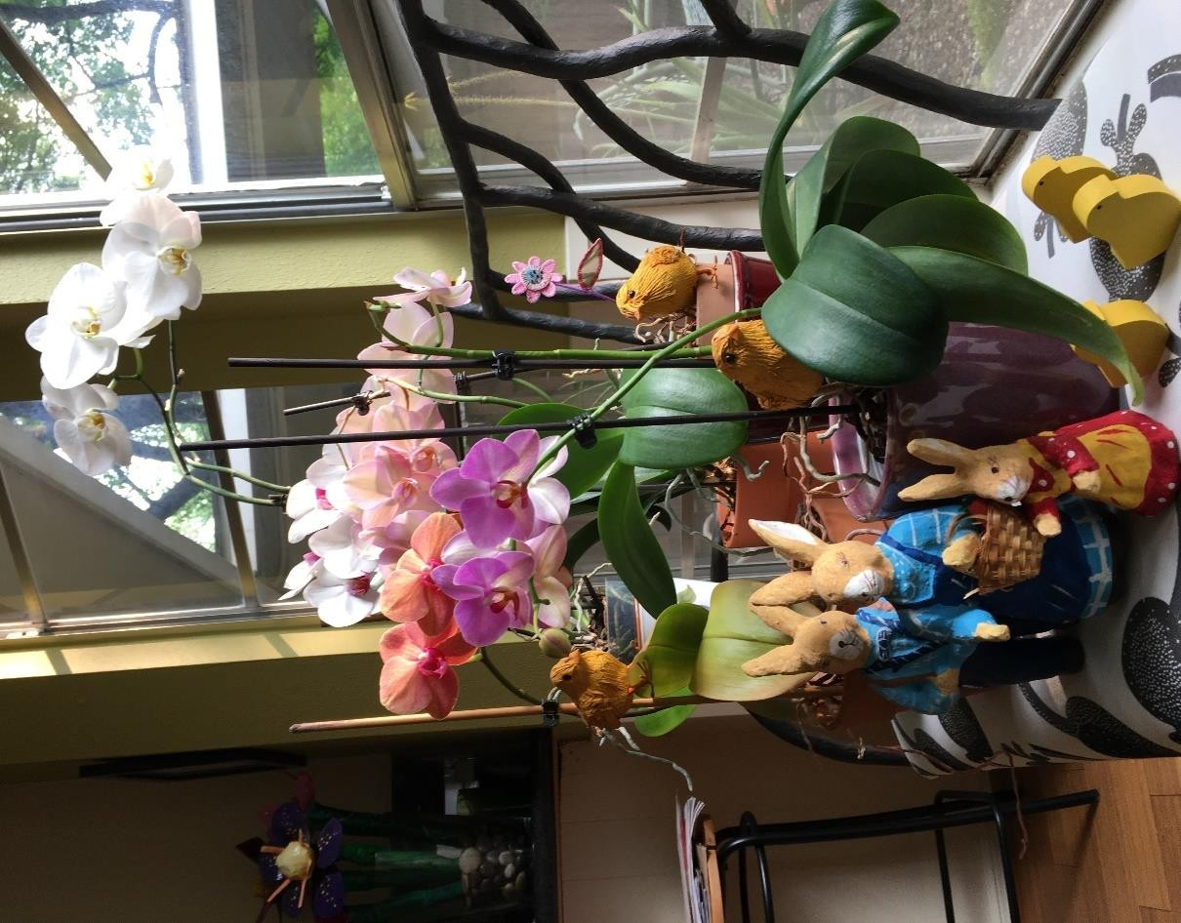
I’m definitely not an expert but I’ll share a few tips for growing and enjoying blooms for years.

My orchid journey began a few years ago when I had a work mate who could grow and rescue any orchid that came into the office. I decided that year to make “Learn to grow an orchid” my new year’s resolution and my office mate was my mentor!

As it turns out they are very easy to grow and will rebloom for years. Here are a few tips I learned from the new year’s resolution:

Watering properly is critical. I water my orchids every 7 to 10 days. Most orchids come planted in a plastic pot with a lot of holes. I take the plastic pot to the sink, run a lot of water over the pot and let it run freely through the planting medium and out the bottom. When all of the excess water has drained out I put them back in their decorative container. This method has kept my orchids happy for years.

Bright light is best. Direct light can burn the leaves. Many of my orchids get bright morning light and rebloom annually under these conditions.

Fertilize sparingly. I have never fed my orchids but have read that it can help growth and blooms. I need to try it!

Repot only when necessary. My mentor told me repotting often does not go well. Orchids like to be root-bound and don’t like being disturbed. I found out the hard way, tried it and lost an orchid. I do add more orchid potting medium when the pot starts looking a bit empty.

Post bloom care. After the flowers fall off I leave the flower stalk on the plant. If it stays green many times new flowers/stalks grow off this original stalk. If the stalk turns brown and dies I cut it off and wait for a new one to eventually sprout.
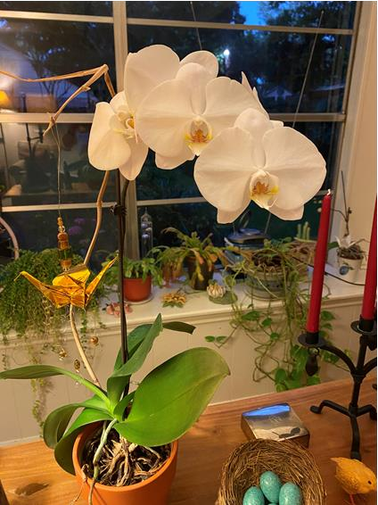

Here is a link to Orchids 101 from the American Orchid Society web page
https://www.aos.org/orchids/orchid-care/orchids-101.aspx
This page will get you started and the website if full of more detailed orchid info…..enjoy!

Wendy Houghton

